# 2. White Box Testing

## I. Rating

**I.I**

**Control**

**Flow**

**Graph**

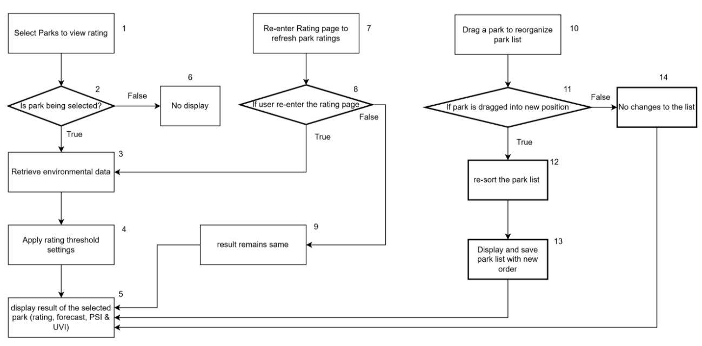

*If the image is unclear, please refer to the raw image file that is uploaded together with this document.*

### I.II Basic Path Testing

**Select Parks to view rating:**

**Cyclomatic Complexity** = | decision points | + 1 = 1 + 1 = 2

#### Basis Paths

1. Baseline path: 1, 2, 3, 4, 5
2. Basis path 2: 1, 2, 6

**Re-enter Rating page to refresh park ratings:**

**Cyclomatic Complexity** = | decision points | + 1 = 1 + 1 = 2

#### Basis Paths

1. Baseline path: 7, 8, 3, 4, 5
2. Basis path 2: 7, 8, 9, 5

**Drag a park to reorganize park list:**

**Cyclomatic Complexity** = | decision points | + 1 = 1 + 1 = 2

#### Basis Paths

1. Baseline path: 10, 11, 12, 13, 5
2. Basis path 2: 10, 11, 14, 5

### I.III Test Cases and Results

|  |  |  |  |  |
| --- | --- | --- | --- | --- |
| **No.** | **Test Input** | **Expected Output** | **Actual Output** | **Pass?** |
| Select Parks to view rating: | | | | |
| 1 | ‘Admiralty Park’ is selected | ‘Admiralty Park’ with weather forecast, PSI, UVI and its rating are displayed on rating page | ‘Admiralty Park’ with weather forecast, PSI, UVI and its rating are displayed on rating page | Yes |
| 2 | ‘Admiralty Park’ is not selected | ‘Admiralty Park’ and its rating are not displayed on rating page | ‘Admiralty Park’ and its rating are not displayed on rating page | Yes |
| Re-enter Rating page to refresh park ratings: | | | | |
| 3 | Selected Park = “Admiralty Park”,  2hr Forecast = “Cloudy”,  PSI = 36,  UVI = 0,  Rating = 5  Click Map icon and then click Rating icon | Admiralty Park’s 2hr forecast, PSI, UVI and rating displayed on rating page are refreshed | Admiralty Park’s 2hr forecast, PSI, UVI and rating displayed on rating page are refreshed | Yes |
| 4 | Selected Park = “Admiralty Park”,  2hr Forecast = “Cloudy”,  PSI = 36,  UVI = 0,  Rating = 5  Stays on rating page | Admiralty Park’s 2hr forecast, PSI, UVI and rating displayed on rating page remains unchanged | Admiralty Park’s 2hr forecast, PSI, UVI and rating displayed on rating page remains unchanged | Yes |
| Drag a park to reorganize park list: | | | | |
| 5 | Drag ‘Admiralty Park’ from top to bottom | ‘Admiralty Park’ is displayed at bottom of selected parks on rating page | ‘Admiralty Park’ is displayed at bottom of selected parks on rating page | Yes |
| 6 | Parks are not dragged | Order of displayed parks on rating page remains unchanged | Order of displayed parks on rating page remains unchanged | Yes |

## II. Rating Config

**II.I**

**Control**

**Flow**

**Graph**

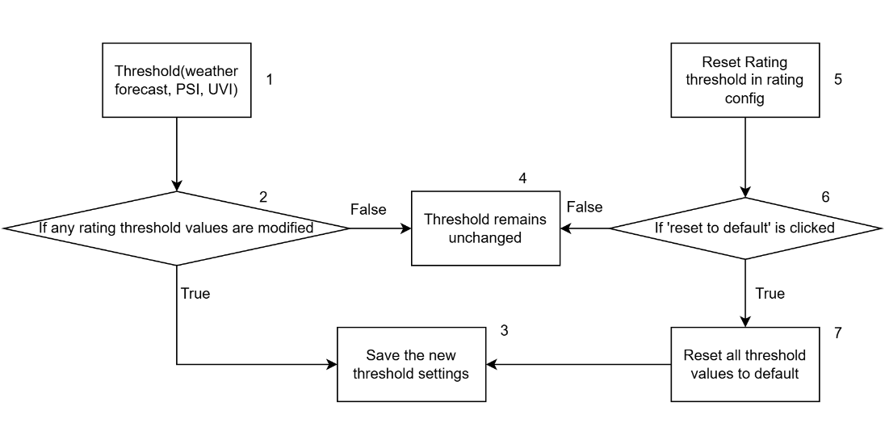

*If the image is unclear, please refer to the raw image file that is uploaded together with this document.*

### II.II Basic Path Testing

**Threshold(weather forecast, PSI, UVI):**

**Cyclomatic Complexity** = | decision points | + 1 = 1 + 1 = 2

#### Basic Paths

1. Baseline path: 1, 2, 3
2. Basis path 2: 1, 2, 4

**Reset rating threshold in rating config:**

**Cyclomatic Complexity** = | decision points | + 1 = 1 + 1 = 2

#### Basic Paths

1. Baseline path: 5, 6, 7, 3
2. Basis path 2: 5, 6, 4

### II.III Test Cases and Results

|  |  |  |  |  |
| --- | --- | --- | --- | --- |
| **No.** | **Test Input** | **Expected Output** | **Actual Output** | **Pass?** |
| Threshold(weather forecast, PSI, UVI): | | | | |
| 1 | Selected Park = “Admiralty Park”,  2hr Forecast = “Cloudy”,  PSI = 36,  UVI = 0,  Rating = 5  2hr Forecast on rating config page:  Previous:  Cloudy = 0  After customization:  Cloudy = -3 | Selected Park = “Admiralty Park”,  2hr Forecast = “Cloudy”,  PSI = 36,  UVI = 0,  Rating = 2 | Selected Park = “Admiralty Park”,  2hr Forecast = “Cloudy”,  PSI = 36,  UVI = 0,  Rating = 2 | Yes |
| 2 | Selected Park = “Admiralty Park”,  2hr Forecast = “Cloudy”,  PSI = 36,  UVI = 0,  Rating = 5  No change made on rating config page | Selected Park = “Admiralty Park”,  2hr Forecast = “Cloudy”,  PSI = 36,  UVI = 0,  Rating = 5 | Selected Park = “Admiralty Park”,  2hr Forecast = “Cloudy”,  PSI = 36,  UVI = 0,  Rating = 5 | Yes |
| Reset rating threshold in rating config: | | | | |
| 3 | Selected Park = “Admiralty Park”,  2hr Forecast = “Cloudy”,  PSI = 36,  UVI = 0,  Rating = 2  2hr Forecast on rating config page:  Cloudy = -3  Click reset button | Selected Park = “Admiralty Park”,  2hr Forecast = “Cloudy”,  PSI = 36,  UVI = 0,  Rating = 5  2hr Forecast on rating config page:  Cloudy = 0 | Selected Park = “Admiralty Park”,  2hr Forecast = “Cloudy”,  PSI = 36,  UVI = 0,  Rating = 5  2hr Forecast on rating config page:  Cloudy = 0 | Yes |
| 4 | Selected Park = “Admiralty Park”,  2hr Forecast = “Cloudy”,  PSI = 36,  UVI = 0,  Rating = 2  2hr Forecast on rating config page:  Cloudy = -3  No action made | Selected Park = “Admiralty Park”,  2hr Forecast = “Cloudy”,  PSI = 36,  UVI = 0,  Rating = 2  2hr Forecast on rating config page:  Cloudy = -3 | Selected Park = “Admiralty Park”,  2hr Forecast = “Cloudy”,  PSI = 36,  UVI = 0,  Rating = 2  2hr Forecast on rating config page:  Cloudy = -3 | Yes |

## III. Notification

**III.I**

**Control**

**Flow**

**Graph**

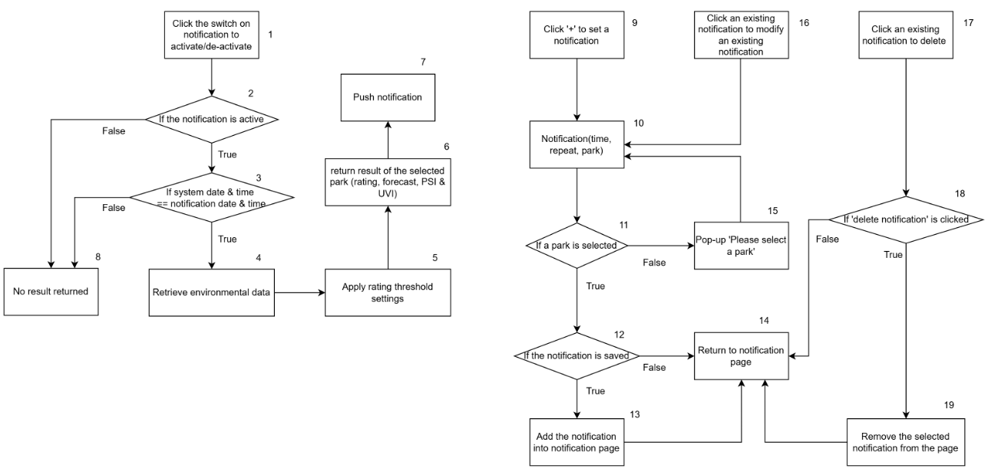

*If the image is unclear, please refer to the raw image file that is uploaded together with this document.*

### III.II Basic Path Testing

**Click the switch on notification to activate/de-activate:**

**Cyclomatic Complexity** = | decision points | + 1 = 2 + 1 = 3

#### Basic Paths

1. Baseline path: 1, 2, 3, 4, 5, 6, 7
2. Basis path 2: 1, 2, 8
3. Basis path 3: 1, 2, 3, 8

**Click ‘+’ to set a notification:**

**Cyclomatic Complexity** = | decision points | + 1 = 2 + 1 = 3

#### Basic Paths

1. Baseline path: 9, 10, 11, 12, 13, 14
2. Basis path 2: 9, 10, 11, 15
3. Basis path 3: 9, 10, 11, 12, 14

**Click an existing notification to modify:**

**Cyclomatic Complexity** = | decision points | + 1 = 2 + 1 = 3

#### Basic Paths

1. Baseline path: 16, 10, 11, 12, 13, 14
2. Basis path 2: 16, 10, 11, 15
3. Basis path 3: 16, 10, 11, 12, 14

**Click an existing notification to delete:**

**Cyclomatic Complexity** = | decision points | + 1 = 1 + 1 = 2

#### Basic Paths

1. Baseline path: 17, 18, 19, 14
2. Basis path 2: 17, 18, 14

### III.III Test Cases and Results

|  |  |  |  |  |
| --- | --- | --- | --- | --- |
| **No.** | **Test Input** | **Expected Output** | **Actual Output** | **Pass?** |
| Click the switch on notification to activate/de-activate: | | | | |
| 1 | Notification:  Time = 08:00,  Repeat every = Saturday, Sunday,  Park = ‘Admiralty Park’  Activation switch is ON | When time = 08:00 on Saturday & Sunday,  Notification sent:  “Admiralty Park,  2hr Forecast = “XXX”,  PSI = X,  UVI = X,  Rating = X” | When time = 08:00 on Saturday & Sunday,  Notification sent:  “Admiralty Park,  2hr Forecast = “XXX”,  PSI = X,  UVI = X,  Rating = X” | Yes |
| 2 | Notification:  Time = 08:00,  Repeat every = Saturday, Sunday,  Park = ‘Admiralty Park’  Activation switch is OFF | No notification sent | No notification sent | Yes |
| 3 | Notification:  Time = 08:00,  Repeat every = Saturday, Sunday,  Park = ‘Admiralty Park’  Activation switch is ON | When time != 08:00 on Saturday & Sunday,  No notification sent | When time != 08:00 on Saturday & Sunday,  No notification sent | Yes |
| Click ‘+’ to set a notification: | | | | |
| 4 | Add Notification:  Time = 08:00,  Repeat every = Saturday, Sunday,  Park = ‘Admiralty Park’  Click Save button | Notification saved and displayed on page:  Time = 08:00,  Repeat every = Saturday, Sunday,  Park = ‘Admiralty Park’  When time = 08:00 on Saturday & Sunday,  Notification sent:  “Admiralty Park,  2hr Forecast = “XXX”,  PSI = X,  UVI = X,  Rating = X” | Notification saved and displayed on page:  Time = 08:00,  Repeat every = Saturday, Sunday,  Park = ‘Admiralty Park’  When time = 08:00 on Saturday & Sunday,  Notification sent:  “Admiralty Park,  2hr Forecast = “XXX”,  PSI = X,  UVI = X,  Rating = X” | Yes |
| 5 | Add Notification:  Time = 08:00,  Repeat every = Saturday, Sunday,  Park = Null  Click Save button | Popup: “Please select a park.” | Popup: “Please select a park.” | Yes |
| 6 | Add Notification:  Time = 08:00,  Repeat every = Saturday, Sunday,  Park = ‘Admiralty Park’  Click blank area or ‘x’ | No notification saved / displayed | No notification saved / displayed | Yes |
| Click an existing notification to modify: | | | | |
| 7 | Click an existing notification:  Time = 08:00,  Repeat every = Saturday, Sunday,  Park = ‘Admiralty Park’  After modification:  Time = 10:00,  Repeat every = Monday,  Park = ‘East Coast Park’  Click Save button | Notification saved and displayed on page:  Time = 10:00,  Repeat every = Monday,  Park = ‘East Coast Park’  When time = 10:00 on Monday,  Notification sent:  “East Coast Park’,  2hr Forecast = “XXX”,  PSI = X,  UVI = X,  Rating = X” | Notification saved and displayed on page:  Time = 10:00,  Repeat every = Monday,  Park = ‘East Coast Park’  When time = 10:00 on Monday,  Notification sent:  “East Coast Park’,  2hr Forecast = “XXX”,  PSI = X,  UVI = X,  Rating = X” | Yes |
| 8 | Click an existing notification:  Time = 08:00,  Repeat every = Saturday, Sunday,  Park = ‘Admiralty Park’  After modification:  Time = 10:00,  Repeat every = Monday,  Park = Null  Click Save button | Popup: “Please select a park.” | Popup: “Please select a park.” | Yes |
| 9 | Click an existing notification:  Time = 08:00,  Repeat every = Saturday, Sunday,  Park = ‘Admiralty Park’  After modification:  Time = 10:00,  Repeat every = Monday,  Park = ‘East Coast Park’  Click blank area or ‘x’ | Notification displayed:  Time = 08:00,  Repeat every = Saturday, Sunday,  Park = ‘Admiralty Park’  When time = 08:00 on Saturday & Sunday,  Notification sent:  “Admiralty Park,  2hr Forecast = “XXX”,  PSI = X,  UVI = X,  Rating = X” | Notification displayed:  Time = 08:00,  Repeat every = Saturday, Sunday,  Park = ‘Admiralty Park’  When time = 08:00 on Saturday & Sunday,  Notification sent:  “Admiralty Park,  2hr Forecast = “XXX”,  PSI = X,  UVI = X,  Rating = X” | Yes |
| Click an existing notification to delete: | | | | |
| 10 | Click an existing notification:  Time = 08:00,  Repeat every = Saturday, Sunday,  Park = ‘Admiralty Park’  Click Delete button | The notification is removed:  Time = 08:00,  Repeat every = Saturday, Sunday,  Park = ‘Admiralty Park’ | The notification is removed:  Time = 08:00,  Repeat every = Saturday, Sunday,  Park = ‘Admiralty Park’ | Yes |
| 11 | Click an existing notification:  Time = 08:00,  Repeat every = Saturday, Sunday,  Park = ‘Admiralty Park’  Delete button is not clicked | No change made on Notification:  Time = 08:00,  Repeat every = Saturday, Sunday,  Park = ‘Admiralty Park’ | No change made on Notification:  Time = 08:00,  Repeat every = Saturday, Sunday,  Park = ‘Admiralty Park’ | Yes |

## IV. Notification

**IV.I**

**Control**

**Flow**

**Graph**

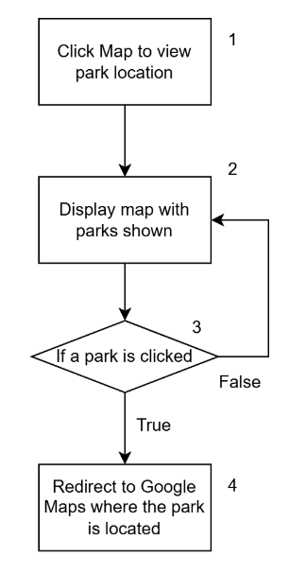

*If the image is unclear, please refer to the raw image file that is uploaded together with this document.*

### IV.II Basic Path Testing

**Click Map to view park location:**

**Cyclomatic Complexity** = | decision points | + 1 = 1 + 1 = 2

#### Basic Paths

1. Baseline path: 1, 2, 3, 4
2. Basis path 2: 1, 2, 3, 2

### IV.III Test Cases and Results

|  |  |  |  |  |
| --- | --- | --- | --- | --- |
| **No.** | **Test Input** | **Expected Output** | **Actual Output** | **Pass?** |
| Click Map to view park location: | | | | |
| 1 | Click Map icon | Map with pinned parks is displayed | Map with pinned parks is displayed | Yes |
| 2 | Click Map icon and click a pinned park = ‘Admiralty Park’ | Redirect to Google Maps with ‘Admiralty Park’ displayed | Redirect to Google Maps with ‘Admiralty Park’ displayed | Yes |